# **Smart parking[Raspberry Pi]**

**Project overview**

A Raspberry Pi is a small, affordable, and versatile computer developed by the Raspberry Pi Foundation. It is designed for educational purposes, but its compact size, low cost, and GPIO (General Purpose Input/Output) pins make it suitable for various DIY and commercial projects.

**Using Raspberry Pi in Smart Parking**

* Raspberry Pi can be utilized in smart parking systems to perform several functions:
* **Data Collection:** Raspberry Pi can be equipped with various sensors, such as ultrasonic or camera modules, to monitor parking space occupancy and gather data in real-time.
* **Data Processing:** The Raspberry Pi can process the data from sensors, such as identifying vacant or occupied parking spaces based on image recognition or distance measurements.
* **Data Storage:** It can store parking data locally or send it to a central server or cloud for analysis, management, and reporting.
* **User Interface:** Raspberry Pi can serve as the user interface for parking lot users. For instance, it can display information about available parking spaces on an LED or LCD display.
* **Integration:** It can be integrated with access control systems, barriers, or gates to control entry and exit from the parking area based on available space and user authentication.
* **Communication:** Raspberry Pi can communicate with a central management system, a mobile app, or web services to provide real-time parking information to users or operator

**Sensors**:

**>>** Ultrasonic sensor



**>>** ,PIRmotion sensor

**>>**  Keypad sensor

**Their Uses:**

**Ultrasonic sensor**

**1 Ultrasonic Sensors:** Ultrasonic sensors are commonly used in smart parking systems to detect the presence of vehicles in individual parking spaces. These sensors emit ultrasonic waves and measure the time it takes for the waves to bounce back. Based on this data, they can determine if a parking space is occupied or vacant.

**PIRmotion sensor:**

**2.PIRmotion sensor**: PIR motion sensors are used in smart parking systems to detect vehicle movement and occupancy in parking spaces. They provide real-time data for space availability, improve security, and help drivers find open spots quickly, reducing congestion. These sensors enhance the overall efficiency and management of parking facilities.

**Keypad sensor:**

**3.Keypad sensor**: Keypad sensors in smart parking systems serve as access control points, allowing users to input codes for entry or exit. They enhance security, restrict unauthorized access, and can facilitate payment validation. Keypad sensors are an integral part of user authentication and control in parking facilities.

**Configured Sensor And PythonScript :**

**Ultrasonic sensor:**

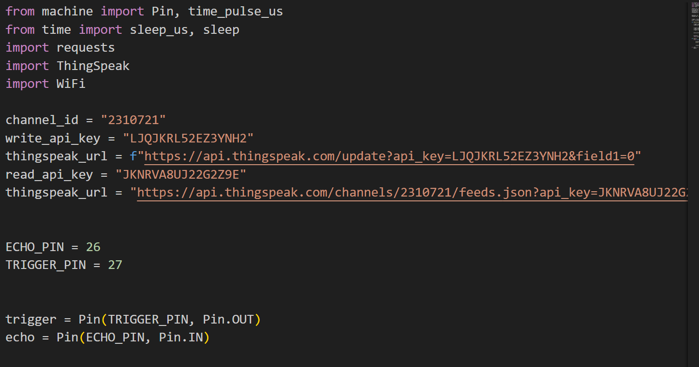

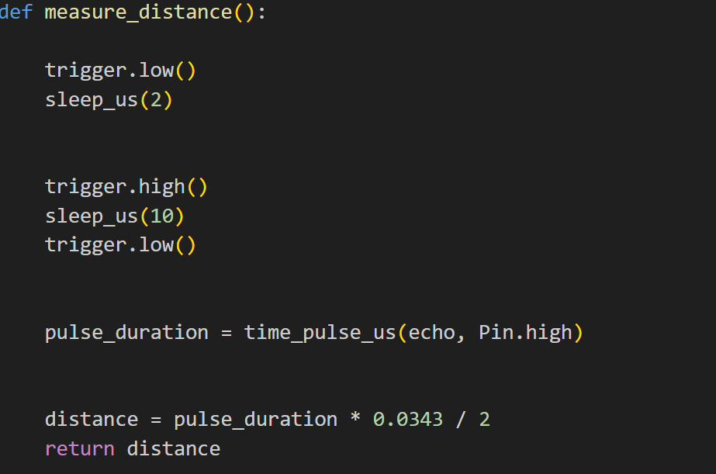

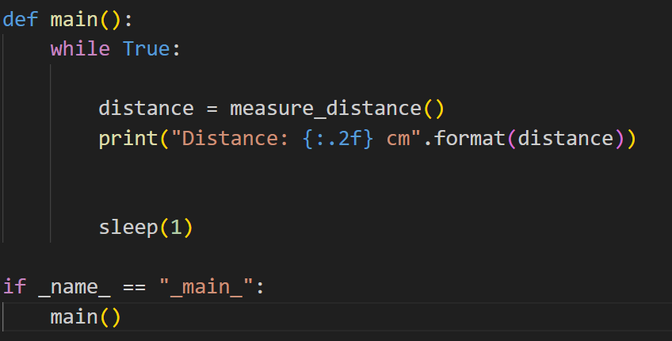

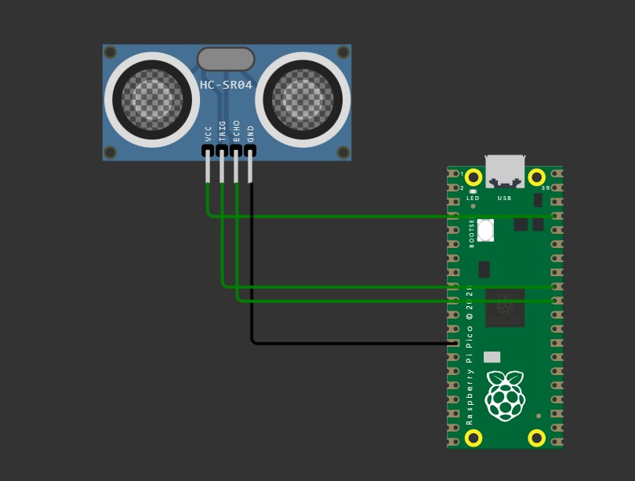

**PIRmotion sensor:**

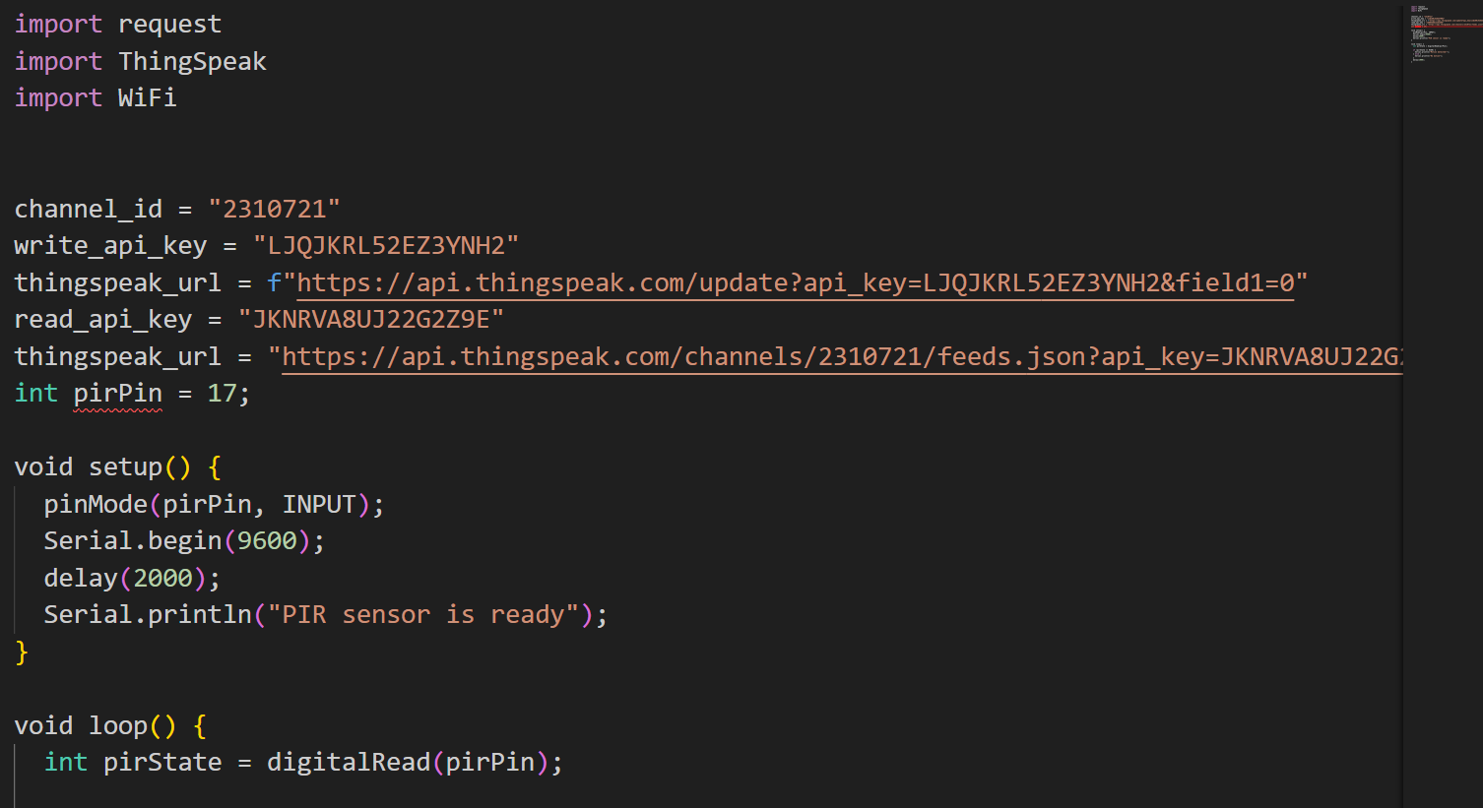

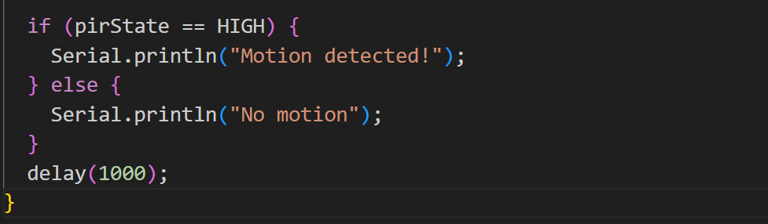

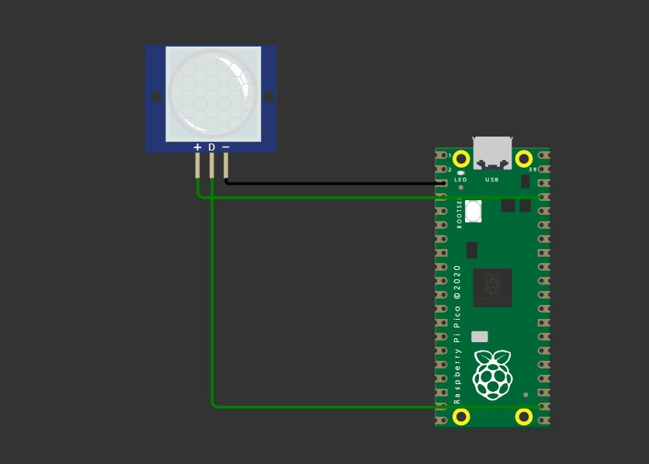

**Keypad sensor:**



